| Experiment No. 2 |
| --- |
| Analyze the Titanic Survival Dataset and Apply appropriate  Regression Technique |
| Date of Performance: 23/7/2024 |
| Date of Submission: 6/8/2024 |

**Aim:** Analyze the Titanic Survival Dataset and Apply appropriate Regression Technique.

**Objective:** Able to perform various feature engineering tasks, apply logistic regression on the given dataset and maximize the accuracy.

# Theory:

Logistic Regression was used in the biological sciences in early twentieth century. It was then used in many social science applications. Logistic Regression is used when the dependent variable(target) is categorical and is binary in nature. In order to perform binary classification the logistic regression techniques makes use of Sigmoid fuction.

For example,

To predict whether an email is spam (1) or (0) Whether the tumor is malignant (1) or not (0)

Consider a scenario where we need to classify whether an email is spam or not. If we use linear regression for this problem, there is a need for setting up a threshold based on which classification can be done. Say if the actual class is malignant, predicted continuous value 0.4 and the threshold value is 0.5, the data point will be classified as not malignant which can lead to serious consequence in real time.

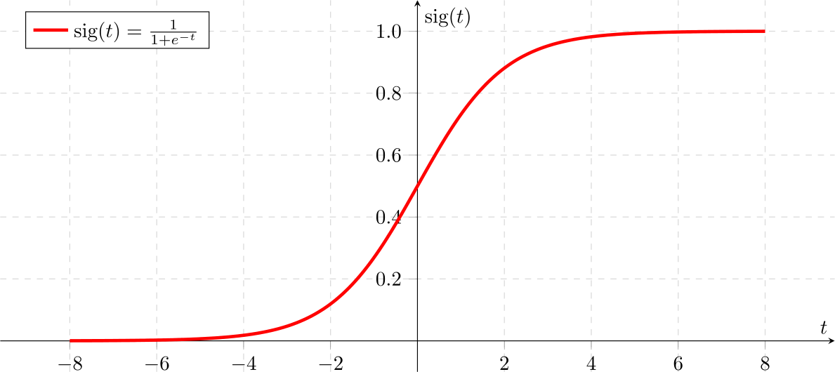

From this example, it can be inferred that linear regression is not suitable for classification problem. Linear regression is unbounded, and this brings logistic regression into picture. Their value strictly ranges from 0 to 1.

# Dataset:

The sinking of the Titanic is one of the most infamous shipwrecks in history.

On April 15, 1912, during her maiden voyage, the widely considered “unsinkable” RMS Titanic sank after colliding with an iceberg. Unfortunately, there weren’t enough lifeboats for everyone onboard, resulting in the death of 1502 out of 2224 passengers and crew.

While there was some element of luck involved in surviving, it seems some groups of people were more likely to survive than others.

In this challenge, we ask you to build a predictive model that answers the question: “what sorts of people were more likely to survive?” using passenger data (ie name, age, gender, socio- economic class, etc).

| **Variable** | **Definition** | **Key** |
| --- | --- | --- |
| survival | Survival | 0 = No, 1 = Yes |
| pclass | Ticket class | 1 = 1st, 2 = 2nd, 3 = 3rd |
| sex | Sex |  |
| Age | Age in years |  |
| sibsp | # of siblings / spouses aboard the Titanic |  |
| parch | # of parents / children aboard the Titanic |  |
| ticket | Ticket number |  |
| fare | Passenger fare |  |
| cabin | Cabin number |  |
| embarked | Port of Embarkation | C = Cherbourg, Q = Queenstown, S = Southampton |

Variable Notes

pclass: A proxy for socio-economic status (SES) 1st = Upper, 2nd = Middle, 3rd = Lower

age: Age is fractional if less than 1. If the age is estimated, is it in the form of xx.5

sibsp: The dataset defines family relations in this way..., Sibling = brother, sister, stepbrother, stepsister

Spouse = husband, wife (mistresses and fiancés were ignored)

parch: The dataset defines family relations in this way... Parent = mother, father

Child = daughter, son, stepdaughter, stepson

Some children travelled only with a nanny, therefore parch=0 for them.

# CODE & OUTPUT:

import pandas as pd

df = pd.read_csv('Titanic-Dataset.csv') print(df.head())

PassengerId Survived Pclass \ 0 1 0 3

1 2 1 1

2 3 1 3

3 4 1 1

4 5 0 3

Name Sex Age SibSp

| 1 Cumings, Mrs. John Bradley (Florence Briggs | Th... | female | 38.0 | 1 |
| --- | --- | --- | --- | --- |
| 2 Heikkinen, Miss. | Laina | female | 26.0 | 0 |
| 3 Futrelle, Mrs. Jacques Heath (Lily May | Peel) | female | 35.0 | 1 |
| 4 Allen, Mr. William | Henry | male | 35.0 | 0 |

Parch Ticket Fare Cabin Embarked 0 0 A/5 21171 7.2500 NaN S

1 0 PC 17599 71.2833 C85 C

2 0 STON/O2. 3101282 7.9250 NaN S

3 0 113803 53.1000 C123 S

4 0 373450 8.0500 NaN S

print(df.info())

<class 'pandas.core.frame.DataFrame'> RangeIndex: 891 entries, 0 to 890 Data columns (total 12 columns):

# Column Non-Null Count Dtype

| 0 |  | PassengerId | 891 | non-null |  | int64 |
| --- | --- | --- | --- | --- | --- | --- |
| 1 |  | Survived | 891 | non-null |  | int64 |
| 2 |  | Pclass | 891 | non-null |  | int64 |
| 3 |  | Name | 891 | non-null |  | object |
| 4 |  | Sex | 891 | non-null |  | object |
| 5 |  | Age | 714 | non-null |  | float64 |
| 6 |  | SibSp | 891 | non-null |  | int64 |
| 7 |  | Parch | 891 | non-null |  | int64 |
| 8 |  | Ticket | 891 | non-null |  | object |
| 9 |  | Fare | 891 | non-null |  | float64 |
| 10 |  | Cabin | 204 | non-null |  | object |
| 11 |  | Embarked | 889 | non-null |  | object |

dtypes: float64(2), int64(5), object(5) memory usage: 83.7+ KB

None

df = df[['Survived', 'Age', 'Sex', 'Pclass']]

df = pd.get_dummies(df, columns=['Sex', 'Pclass']) df.dropna(inplace=True)

print(df.head())

Survived Age Sex_female Sex_male Pclass_1 Pclass_2 Pclass_3

1. 0 22.0 False True False False True
2. 1 38.0 True False True False False
3. 1 26.0 True False False False True
4. 1 35.0 True False True False False
5. 0 35.0 False True False False True

print(df)

|  | Survived | Age | Sex_female | Sex_male | Pclass_1 | Pclass_2 | Pclass_3 |
| --- | --- | --- | --- | --- | --- | --- | --- |
| 0 | 0 | 22.0 | False | True | False | False | True |
| 1 | 1 | 38.0 | True | False | True | False | False |
| 2 | 1 | 26.0 | True | False | False | False | True |
| 3 | 1 | 35.0 | True | False | True | False | False |
| 4 | 0 | 35.0 | False | True | False | False | True |
| .. | ... | ... | ... | ... | ... | ... | ... |
| 885 | 0 | 39.0 | True | False | False | False | True |
| 886 | 0 | 27.0 | False | True | False | True | False |
| 887 | 1 | 19.0 | True | False | True | False | False |
| 889 | 1 | 26.0 | False | True | True | False | False |
| 890 | 0 | 32.0 | False | True | False | False | True |
| [714 | rows x 7 | columns] | | | | | |

from sklearn.model_selection import train_test_split x = df.drop('Survived', axis=1)

y = df['Survived']

x_train, x_test, y_train, y_test = train_test_split(x, y, test_size=0.2, s tratify=y, random_state=0)

from sklearn.linear_model import LogisticRegression

model = LogisticRegression(random_state=0) model.fit(x_train, y_train)

LogisticRegression(random_state=0) model.score(x_test, y_test) 0.8321678321678322

from sklearn.model_selection import cross_val_score

cross_val_score(model, x, y, cv=5).mean() 0.7857480547621394

from sklearn.metrics import confusion_matrix

y_predicted = model.predict(x_test) confusion_matrix(y_test, y_predicted)

array([[78, 7],

[17, 41]])

from sklearn.metrics import ConfusionMatrixDisplay, confusion_matrix import matplotlib.pyplot as plt

y_pred = model.predict(x_test)

*# Compute the confusion matrix*

cm = confusion_matrix(y_test, y_pred)

*# Display the confusion matrix*

disp = ConfusionMatrixDisplay(confusion_matrix=cm, display_labels=['Perish ed', 'Survived'])

disp.plot(cmap='Blues')

*# Optional: customize the plot further* plt.xticks(rotation='vertical') plt.title('Confusion Matrix') plt.show()

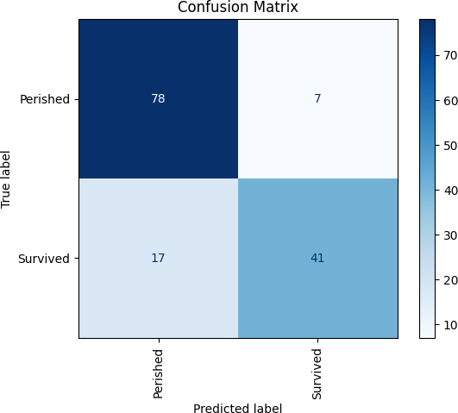

from sklearn.metrics import classification_report print(classification_report(y_test, y_predicted))

|  | precision | recall | f1-score | support |
| --- | --- | --- | --- | --- |
| 0 | 0.82 | 0.92 | 0.87 | 85 |
| 1 | 0.85 | 0.71 | 0.77 | 58 |
| accuracy |  |  | 0.83 | 143 |
| macro avg | 0.84 | 0.81 | 0.82 | 143 |
| weighted avg | 0.83 | 0.83 | 0.83 | 143 |

accuracy = model.score(x_test, y_test) print(f'Accuracy: {accuracy:.2f}')

Accuracy: 0.83

from sklearn.metrics import roc_curve, RocCurveDisplay y_prob = model.predict_proba(x_test)[:,1]

fpr, tpr, _ = roc_curve(y_test, y_prob)

*# Create the ROC curve display*

disp = RocCurveDisplay(fpr=fpr, tpr=tpr) disp.plot()

*# Add labels and title if desired* plt.title('ROC Curve') plt.xlabel('False Positive Rate') plt.ylabel('True Positive Rate')

plt.show()

WARNING:matplotlib.legend:No artists with labels found to put in legend. Note that artists whose label start with an underscore are ignored when le gend() is called with no argument.

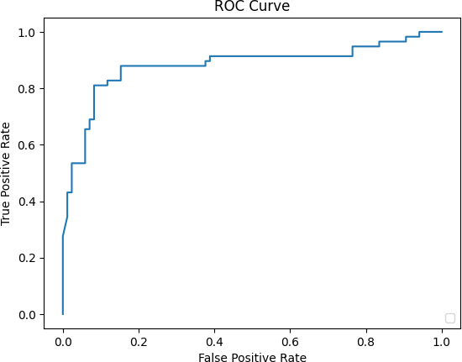

# Conclusion:

The accuracy obtained from the Logistic Regression model on the Titanic dataset provides an overall measure of the model's performance, indicating the proportion of correct predictions out of the total instances. However, accuracy alone can be misleading, especially in the presence of imbalanced classes. For instance, if there are significantly more non-survivors than survivors, a high accuracy might still mean the model predominantly predicts the majority class. Therefore, while a high accuracy suggests good performance, it is essential to also consider other metrics like precision, recall, F1-score, and the ROC curve to comprehensively evaluate the model's ability to correctly predict both survivors and non-survivors. The provided script includes these additional metrics to ensure a more thorough assessment of the model.